**RoboMaster EP Core Tennis Ball Collection and Basket Placement**

*Report by: Ayemon Baraka*

*Department of ECE, UNLV*

The Robomaster EP Core Tennis Ball Collection and Placement System is a project aimed at utilizing the Robomaster EP Core to collect tennis balls and place them into a basket. The system employs computer vision techniques using OpenCV in Python to detect the tennis balls and using the robotic arm and gripper, it collects the balls and places the balls into the basket. Additionally, a marker is attached to the basket, enabling the robot to accurately locate and deposit the balls.

**Work Procedure:**

The project consists of the following steps:

1. Tennis Ball Detection:

The Robomaster EP Core utilizes its onboard camera to capture the live video feed. Computer vision techniques, implemented using OpenCV in Python, are employed to process the video frames and identify tennis balls. Techniques such as color thresholding and contour detection are utilized to detect and isolate the tennis balls in the video feed.

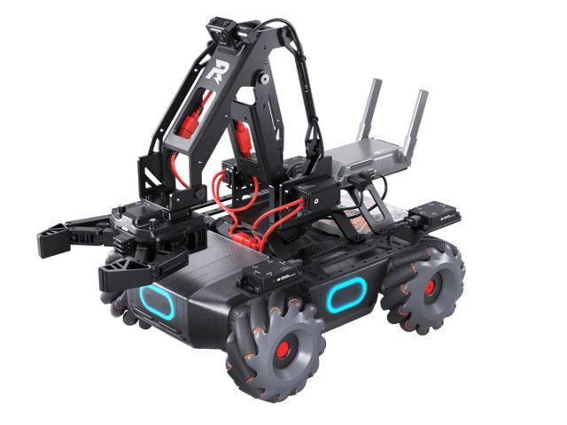

Figure : Robomaster EP Core

1. Robotic Arm Manipulation:

Once a tennis ball is detected, the Robomaster EP Core activates its robotic arm to approach and grasp the ball. The robotic arm's movements are programmed to ensure accurate and stable ball grasping. The grasping mechanism consists of a gripper that can securely hold the tennis ball.

1. Marker Detection:

The designated basket is equipped with a marker, which serves as a visual reference for the robot. The robot's camera, aided by computer vision techniques, identifies and localizes the marker in the video feed. The marker detection provides a precise location for ball placement, ensuring accurate depositing of the balls into the basket.

1. Ball Placement:

Once the marker is detected, the robot moves towards the basket, aligning itself with the marker's position. The robotic arm then releases the tennis ball, placing it inside the basket.

The system repeats the ball detection, grasping, and placement process until all the balls have been collected and deposited.

**Components:**

1. Robomaster EP Core
2. Tennis Balls
3. Basket
4. Marker

**Practical Implementation with Code:**

1. Setting up Robomaster Ep Core

Turn on the Robomaster EP Core robot and ensure that your PC is connected to the robot using direct connection mode.

Figure : Direct Connection

1. Install Python:

Download and install Python on your computer. Visit the official Python website (https://www.python.org) and download Python 3.8. Follow the installation instructions provided for your specific operating system.

1. Clone the GitHub Repository:

Open a terminal or command prompt on your computer and navigate to the directory where you want to clone the project repository. Execute the following command to clone the repository:

*git clone https://github.com/AyemonBaraka/Robomaster_Ep_Core_Fetch_Tennis.git*

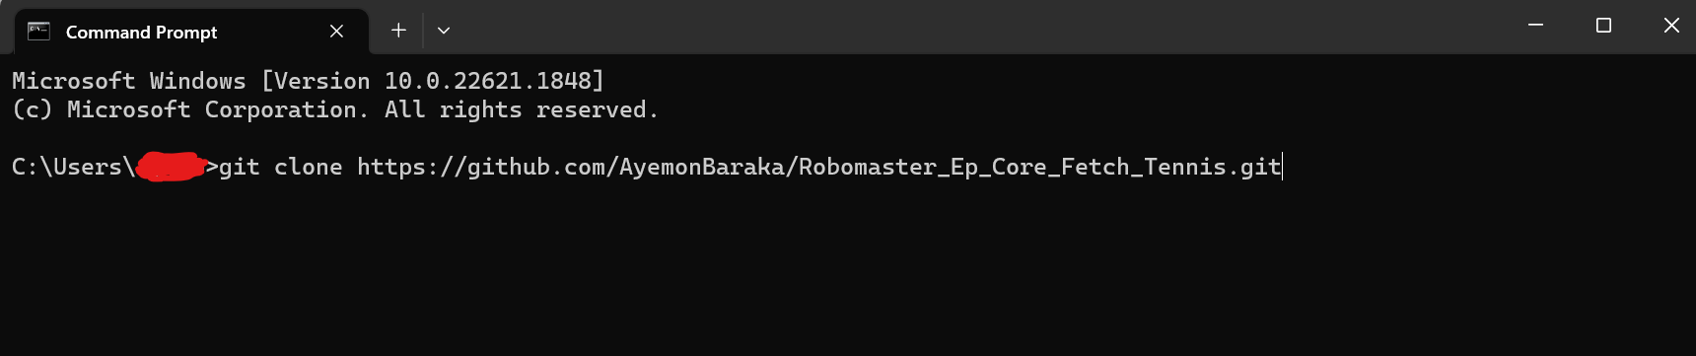

This will create a local copy of the project repository on your computer. Alternatively, you can download the project code directly from the GitHub repository.

1. Install requirements:

Navigate to the cloned repository directory and Install the required Python packages by executing the following command:

*pip install -r requirements.txt*

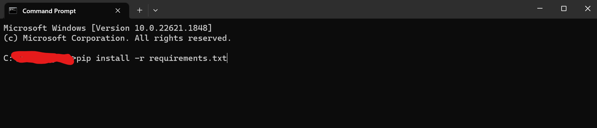

1. Run the code

Make sure your Robomaster EP Core robot is turned on and connected to your computer. Execute the following command to run the project code.

*python epcore_fetch_tennis.py*

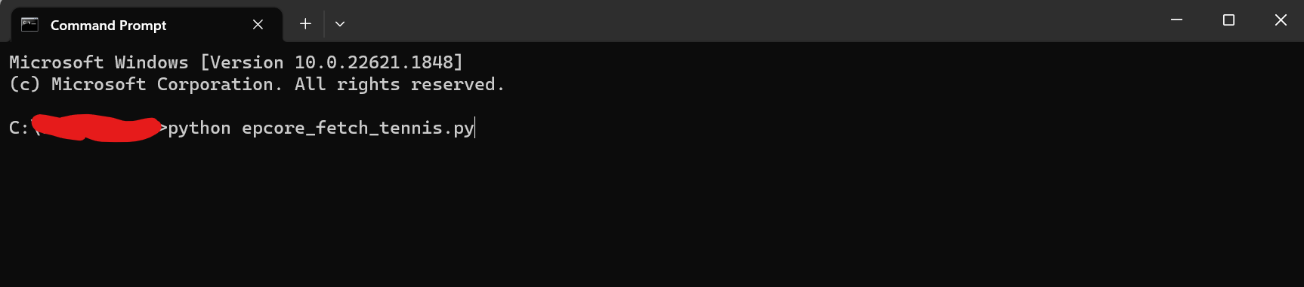

This will start the program and initiate tennis ball detection, robotic arm and gripper control, and marker detection processes.

Links:

Code: <https://github.com/AyemonBaraka/Robomaster_Ep_Core_Fetch_Tennis>

Demo Video: <https://youtu.be/_1uoPFxSp0E>